# DHT-11/22 Temperature and Humidity Sensor

1. How it works:

This sensor is very popular with people who are interested in understanding the weather. It is a sensor that gives digital values of temperature and humidity with good accuracy.

It consists of a Capacitive humidity sensor, a thermistor (a resistance which changes value based on the temperature), and a microchip that takes the analog data and converts it into digital format.

## 2. Applications and Specifications

This sensor has the following features:

* Ultra low cost
* 3 to 5V power and I/O
* 2.5mA max current use during conversion (while requesting data)
* Good for 20-80% humidity readings with 5% accuracy
* Good for 0-50°C temperature readings ±2°C accuracy
* No more than 1 Hz sampling rate (once every second)
* Body size 15.5mm x 12mm x 5.5mm
* 4 pins with 0.1" spacing

It is popularly used in DIY weather stations and environment monitors. It can also be used to predict rain, although that’s not very reliable. The internet is full of projects for using these sensors.

# 3. Connections

1. Sensor pins: There are 3 pins on this sensor, and they are as follows:
2. VCC
3. Data out
4. Ground

b) The following pins are connected to the Arduino:

This diagram shows how we will connect for the testing sketch. Connect data to pin 2, you can change it later to any pin.

|  |  |
| --- | --- |
| Arduino pins | Sensor Pin |
| 5V | VCC |
| GND | GND |
| Digital Pin 2 | Data out |

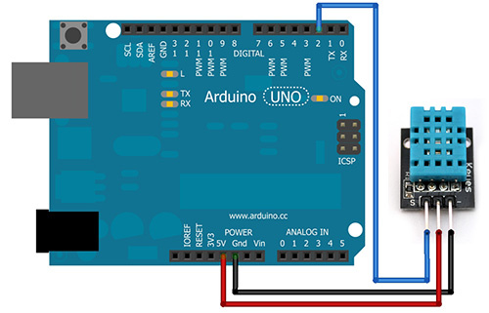

4. Library required for working of distance sensor: DHT Sensor Library

1. Open Arduino IDE
2. Go to sketch>include library>Manage Library
3. A new window will open, search for DHT sensor library and install it.

**5. Errors and Troubleshooting**

1. **If the temperature and humidity is showing in hundreds, the you have to check whether the sensor you have connected is DHT11 or DHT 22 and uncomment the respective sensor line in the sketch**
2. **If you are getting no readings, check your wiring. The error is almost always there**
3. **Check baud rate if the serial monitor indicates weird readings.**